MWC CONCIERGE MEETING SERVICES
Introduction

- Using the briefing document found below, you will brief us on the event or format of meeting that you need our help finding guests for. You will tell us about your company and value to your customers and any supporting marketing material we can use in the outreach

- You will then also brief us on your ideal target prospects to attend these meetings or event, looking at their demographics and key target companies

- A dedicated meeting services account manager is assigned to you specifically for the meeting services project, to work with you to define the value proposition, USPs, onsite meeting logistics and communication flow according to your needs

- The Account Manager works with our team of delegate outreach specialists to personally engage and secure meetings with your pre-qualified selections on your behalf. The delegate outreach team are experienced multi-lingual professionals, well-briefed and well-versed in securing meetings with high-level industry professionals

- You are given access to a real-time agenda of appointments as it is being filled with qualified, confirmed and briefed meetings

- The dedicated onsite team will assist in helping your guests reach their meetings with you during MWC, sharing reminders and guiding them onsite

MWC Concierge Meeting Services

Information Requirements
Q1.0
Who will be the main point of contact for this meeting services project for MWC 2025?

Name | Agathe BRUN
Role in this process | Main point of contact
Position | Regional Marketing Manager
Email | Agathe.Brun@intelsat.com
Work number year-round | +352 661 999 272
Onsite MWC number | +352 661 999 272
Q1.1
Who will attend or present the meeting/event at MWC 2025 from your organisation?

Name | Antonio Bove
Role in this process | Coordinating Europe accounts
Position | Managing Sales Director, Europe
Email | Antonio.bove@intelsat.com
Work number year-round | +352 621 273 142
Onsite MWC number | +352 621 273 142

Q1.2
For executive meetings booked on your stand or meeting room, please confirm the stand number.
For events such as roundtables, please confirm the date, time, location and duration in Q7.1
Hall 4, Stand 4E10

Content, messaging and marketing material
Q2.0
The purpose here is to get an understanding of the core value proposition & unique selling points that will be utilized by the audience acquisition team in their outreach activities when communicating with prospects for the meeting scheduling. In a paragraph or two (300- 500 words), please outline:
- What the core value proposition is and what the USPs are?
- Why should the target prospect be interested? How are we helping them?
- What challenges do we solve/address?

For this event, we want to focus specifically on the enterprise and MNOs verticals.
Delivering connectivity services solely through terrestrial network infrastructure can come with economic, feasibility, and reliability challenges, especially when connecting in remote areas, developing regions, or where immediate establishment of services is crucial.
Carriers, MNOs, and other telecommunications providers have turned to Intelsat for solutions to expand networks and bring predictable service to more users.

MNOs:

Managed Cellular Backhaul
Intelsat CellBackhaul is a fully managed cellular backhaul service where Intelsat manages all the satellite components connecting towers to the MNOs’ core. With quick deployment time and economical delivery of connectivity enabling reliable 2G, 3G, 4G, 5G, and IoT, MNOs can keep their business growing and their customers happy.

Example/use case: an MNO leveraging Intelsat CellBackhaul as they are looking at expanding their 4G coverage to more subscribers in remote or rural areas where fiber and microwave technologies are hard or impossible to deploy. The expansion of their mobile coverage with the deployment of the CellBackhaul solution also enabled the MNO to comply with the country regulations and meet the associated coverage targets.

Enterprise: Making enterprise-grade networking more widely accessible than ever, Intelsat Enterprise Networking services provide the critical lifeline needed to fuel innovation and digital transformation strategies through secure, reliable private networking, SD-WAN and cloud connectivity, and internet access for proven dependability, vast reach, and fast deployment.

IoT
Industrial IoT has moved beyond supporting a trickle of data from a few remote sensors. Now expectations include supporting real-time, always-on connectivity for both monitoring and control.
Using Intelsat FlexEnterprise for IoT backhaul to complement cellular and terrestrial connectivity can extend the reach and effectiveness of your IoT deployments and drive better results for you and your customers.
With an end-to-end satellite backhaul solution ready to plug into your existing network, FlexEnterprise IoT opens new use cases for your organization. By extending IoT connectivity globally – regardless of local cellular and fiber availability – you’ll incorporate devices and infrastructure from every enterprise location to drive forward your organization’s digital initiatives.
From low-data-rate SCADA to richer IP-based connectivity incorporating video and high-throughput data streams, FlexEnterprise IoT helps you address requirements for every site, device, and sensor.

Example/use case: a company leveraging Intelsat FlexEnterprise solution as they are expanding their presence in new geographical areas with limited or unexistant fiber connectivity, or when connectivity backup is needed.

At MWC 2023, Intelsat announced that Deutsche Telekom IoT (DT IoT) intended to integrate Intelsat FlexEnterprise into its cloud-based Internet of Things (IoT) offering to extend powerful, easy-to-use IoT solutions to locations regardless of the availability of fiber or cellular connectivity options. By using FlexEnterprise to complement cellular connectivity, DT can extend the reach and effectiveness of its solution and drive better results for its customers. Read more.

LEO and Multi-Orbit services
In addition to Intelsat’s global GEO (geosynchronous orbit) services, we provide lower-latency LEO (low-Earth orbit) services that combine high-throughput connectivity with end-to-end satellite solution management to meet the expectations of telcos, MNOs, and their enterprise customers.GEO and LEO capacity are available as standalone services or as managed multi-orbit solutions, combining the benefits of GEO and LEO services in a fully integrated solution.
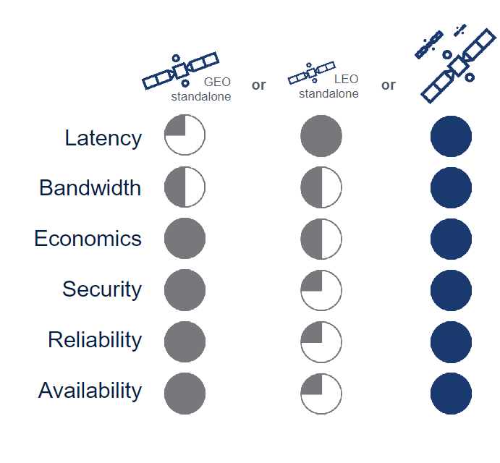

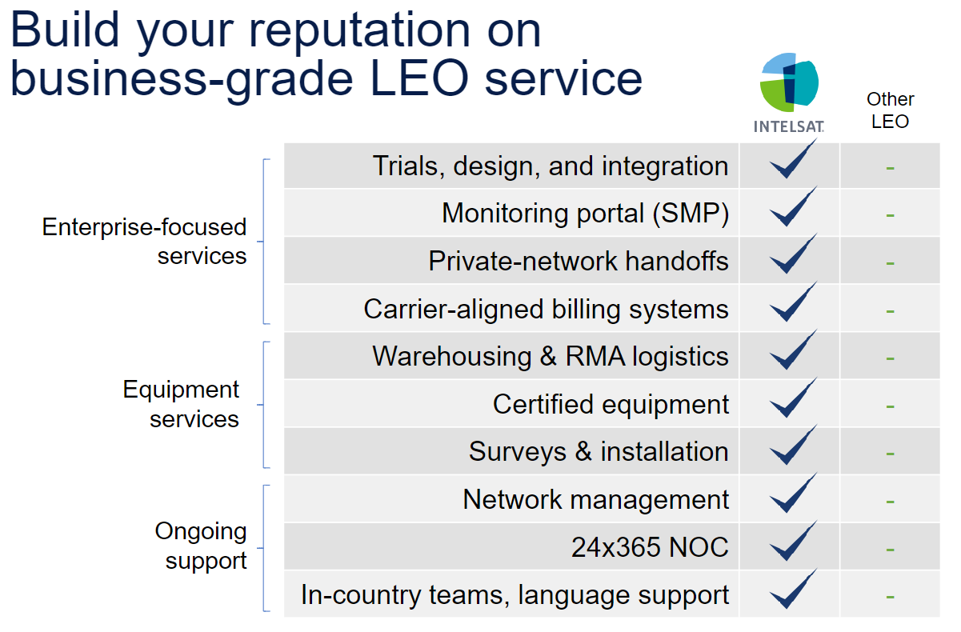

Marketing material/content:
Q2.1
Please provide specific marketing collateral to support the above key messaging.
Please include:
- 1 x company brief presentation
- Links to the website or dedicated MWC landing page
- (optional) 1 or more Product/Service whitepaper(s) see attached ebook

Intelsat’s global team of professionals is focused on providing seamless and secure, satellite-based communications to government, NGO and commercial customers through the company’s next-generation global network and managed services. Bridging the digital divide by operating one of the world’s largest and most advanced satellite fleet and connectivity infrastructures, Intelsat enables people and their tools to speak over oceans, see across continents and listen through the skies to communicate, cooperate and coexist. Since its founding six decades ago, the company has been synonymous with satellite-industry “firsts” in service to its customers and the planet. Leaning on a legacy of innovation and focusing on addressing a new generation of challenges, Intelsat team members now have their sights on the “next firsts” in space as they disrupt the field and lead in the digital transformation of the industry.

- The world’s largest integrated satellite and terrestrial network
- Unparalleled coverage extending to 99% of the world’s populated regions, powered by a fleet of over 50 global satellites and 120+ PoPs to guarantee redundancy
- A commitment to innovation through ongoing partnerships and investments in next generations solutions to enable ubiquitous IoT and 5G services
- A robust, secure, multi-layered infrastructure, relied upon by the world’s governments, telecoms and media companies, and essential to global operations
- The highest security posture in the industry, meeting or exceeding all DoD cybersecurity standards and the only operator with a third-party Service Organization Controls (SOC-3) accreditation through KPMG
https://www.intelsat.com/isps-mnos-telcos/
Target Prospects Brief
Target Companies
Q3.0
If you have a target list of companies (Prospect customers, partners, analysts etc.) that you would like us to prioritise, when looking for target individuals, please share a list, preferably of at least 40:

Country | Operator | Group
Austria | 3 Austria | CK Hutchison Group
Austria | Hofer Telecom | Hofer Group
Austria | Magenta | Deutsche Telekom Group
Austria | Telekom Austria | Telekom Austria Group
Belgium | Telenet Belgium | Liberty Global Group
Bulgaria | A1 Bulgaria | Telekom Austria Group
Bulgaria | Telenor Bulgaria | PPF Group
Croatia | A1 Croatia | Telekom Austria Group
Czech Republic | O2 Czech Republic | O2 Czech Republic Group
Czech Republic | T-Mobile Czech Republic | Deutsche Telekom Group
Czech Republic | Vodafone Czech Republic | Vodafone Group
France | Bouygues Telecom | Bouygues Group
France | Coriolis Telecom | Privately owned
France | EI Telecom | Credit Mutuel
France | Free | Iliad Group
France | Orange | Orange Group
France | SFR France | Altice Group
Germany | Deutsche Telekom | Deutsche Telekom Group
Germany | Freenet Mobile | Publicly listed
Germany | Tchibo Mobil | Tchibo Holding
Germany | Telefonica O2 | Telefonica Group
Germany | United Internet | United Internet Group
Germany | Vodafone Germany | Vodafone Group
Greece | Cosmote | Cosmote Group
Greece | Vodafone Greece | Vodafone Group
Greece | Wind Hellas | Privately owned
Hungary | Telekom Hungary | Magyar Telekom Group
Hungary | Telenor Hungary | PPF Group
Hungary | Vodafone Hungary | Vodafone Group
Italy | Fastweb | Swisscom group
Italy | Telecom Italia | Telefonica Group
Italy | Vodafone Italia | Vodafone Group
Italy | Wind Tre | CK Hutchison Group
Kazakhstan | Altel | Deactivated actor
Kazakhstan | Beeline Kazakhstan | Veon Group
Kazakhstan | KCell | Telia Group
Kazakhstan | Tele2 Kazakhstan | Tele2 Group
Kosovo | Ipko | Telekom Slovenije Group
Kosovo | Vala | Government owned
Poland | Play | Olympia Development
Poland | Polsat | Polsat Group
Poland | T-mobile Poland | Deutsche Telekom Group
Romania | Telekom Romania | Cosmote Group
Romania | Vodafone Romania | Vodafone Group
Saudi | STC | STC Group
Serbia | MTS Srbija | Telekom Srbija Group
Serbia | Telenor Serbia | PPF Group
Serbia | Vip Serbia | Telekom Austria Group
Slovakia | O2 Slovakia | O2 Czech Republic Group
Slovakia | Slovak Telecom | Deutsche Telekom Group
Slovenia | A1 Slovenia | Telekom Austria Group
Slovenia | Telekom Slovenije | Telekom Slovenije Group
Switzerland | Salt | NJJ Capital
Switzerland | Sunrise | Publicly listed
Switzerland | Swisscom | Swisscom group
UAE | e& | Emirates Telecommunications Group Company PJSC
UK | 3 UK | CK Hutchison Group
UK | EE | BT Group
UK | O2 UK | Telefonica Group
UK | Vodafone UK | Vodafone Group
Ukraine | Intertelecom | Privately owned
Ukraine | Kyivstar | Veon Group
Ukraine | Lifecell | Turkcell Holdings Group
Ukraine | Ukrtelecom | SCM
Ukraine | Vodafone Ukraine | MTS Group

Country | Towerco
France | TOTEM
Germany | Vantage Towers
India | Indus Tower
Spain | Cellnex
United Kingdom | Helios Towers
United Kingdom | HIS Towers
United States | American Tower
United States | Crown Castle
United States | PTI
United States | SBA

Company main activity
Q4.0
Please additionally select as many of these company types as are relevant to your target prospects. You will also be able to outline industry areas later:

AGRITECH/AGRIFOOD | FINANCE/BANKING/INSURANCE | MEDIA/ENTERTAINMENT - GAMING/VIRTUAL REALITY/AR
APP/SOFTWARE DEVELOPMENT | GOVERNMENT/REGULATORY BODIES | MOBILE NETWORK OPERATOR
ASSOCIATION/NOT-FOR-PROFIT | HEALTHCARE/BIOTECH/PHARMA | MOBILE VIRTUAL NETWORK OPERATOR
AUTOMOTIVE/TRANSPORTATION | INFORMATION/ANALYTICS/BUSINESS INFORMATION | NETWORK INFRASTRUCTURE VENDOR
CLOUD SERVICES | IOT/M2M | OTHER
CONSULTANCY | MANUFACTURING - DEVICES & WEARABLES | RETAIL/E-COMMERCE
CYBERSECURITY/CONTROLS/DATA SECURITY | MANUFACTURING - IT/HARDWARE | SYSTEMS INTEGRATOR
EDUCATION/TRAINING | MANUFACTURING - SOFTWARE | VENTURE CAPITAL/INVESTMENT/M&A
EVENT COMPANY/EVENT SUPPORT
Companies to Exclude
Q5.0
If you would like us to exclude certain companies from the program (such as existing customers, competitors etc.) please detail them here:

SES
Eutelsat
Starlink
Kuiper

(Business Areas/ Job Titles)
Q6.0
Finally, please tell us about the business areas that your target prospects work in via the list below or provide a list of target areas below:
ADVISORY/STRATEGY/PLANNING/  PERFORMANCE | INFORMATION/DIGITAL/ANALYTICS | PRESS/MEDIA
BUSINESS DEVELOPMENT/SALES/PRODUCT MGMT | INVESTMENT/VENTURE CAPITAL/M&A | RESEARCH/DEVELOPMENT/INNOVATION
CLIENT/CUSTOMER SERVICE | LEGAL/IP | SOFTWARE/DEVELOPER
CONTENT DEVELOPMENT/DISTRIBUTION | MANUFACTURING | SOURCING/PROCUREMENT
FINANCE/ACCOUNTING | MARKETING/ADVERTISING/PR | SUPPLY CHAIN MGMT/DISTRIBUTION
GOVERNMENT/REGULATORY | OPERATIONS MGMT | TECHNICAL/ENGINEERING
HR/TALENT/DIVERSITY | Other | TRAINING/EDUCATION

Q6.1
If there are specific job titles or work areas that you would like to focus on, please detail them here:

Networks: MNOs, Telcos, ISPs, Integrated Operators.
Top Network Planning Executive, Top Network Service Executive, Top Telecommunications Executive, Chief Network Planning Executive, Chief Network Service Executive, Chief Telecommunications Officer, Network Operations Manager, Network Planning Manager, Strategic Planning Manager, Strategic Planning Director, Field Service Engineer, Head of Network Service, Network Service Director, Network Service Manager, Telecommunications Engineer III-V, Telecommunications Network Engineer III-V, Vice President of Installation & Maintenance, Vice President of Network Planning, Vice President of Network Service, Business Continuance/Disaster Recovery Manager, Business Resumption Planning and Strategy Director, Contingency Planning Director, Contingency Planning Manager, Disaster Recovery Director, Disaster Recovery Manager, Disaster Recovery Planning and Implementation Manager, Disaster Recovery Planning and Strategy Director, Engineering Program/Project Management Manager, Lead RF Engineer, Manager Engineering Design/Development Projects, Principal RF Engineer, Principal/Lead Radio Frequency Engineer, Project Engineering Manager, Radio Frequency Engineer III-V, RF Engineer III-V, Risk and Business Continuance Planning Director, Senior Radio Frequency Engineer, Senior RF Engineer, Telecommunications Analysis Manager, Telecommunications Director, Telecommunications Manager, Telecommunications Supervisor, Telecommunications/Mobility Services Director, Telecommunications/Mobility Services Manager.

For executive attendance at an event such as a roundtable/lunch briefing etc instead of executive meetings in a meeting room or on a stand, please also let us know about these supplementary questions:
Q7.0
Please confirm the type of event you are sourcing meeting guests for:
- Roundtable / Workshop / Demo Session
- Breakfast or Lunch briefing / Cocktail reception / Private Dinner

Q7.1
Please advise on the date, time, duration and location the session will take place.

Content / Key messages

Q7.2
Please tell us the theme / title of the event
Q7.3
Please provide a detailed agenda of the topics to be discussed / showcased
Q7.4
Please provide a list of the speakers / experts participating, with their name and bio
Q7.5
Is there any additional value on offer to meeting guests, such as a recording of the event or access to a new report/research?

